**Lab 12**

**Enhance a web application by using the Azure Content Delivery Network**

**Exercise 1:** Create Azure resources

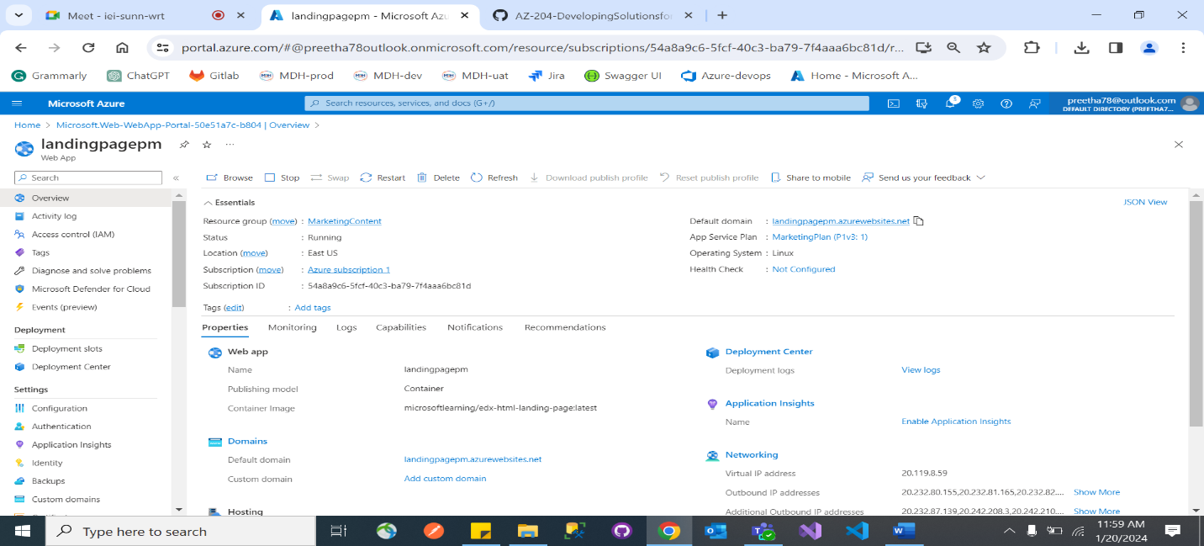

**Exercise 2:** Configure Content Delivery Network and endpoints

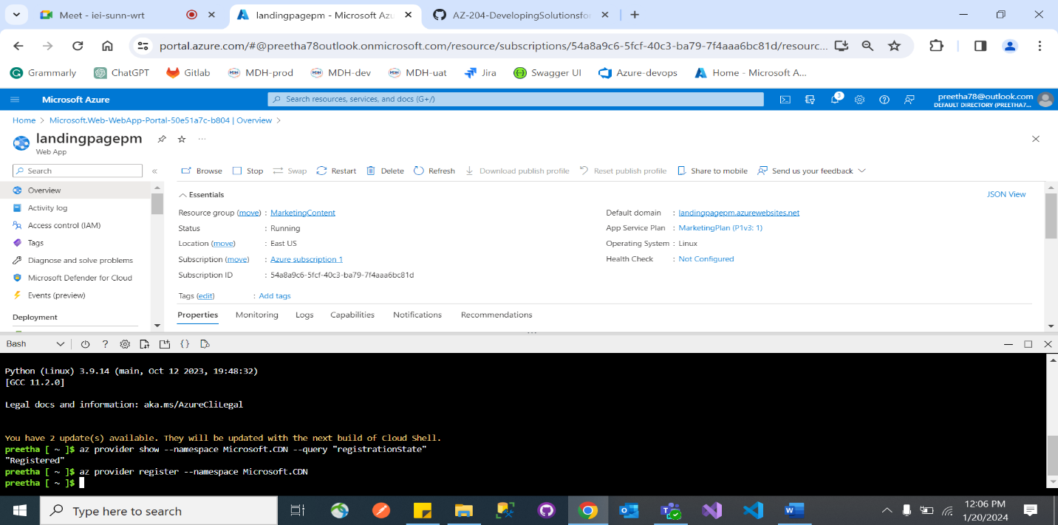

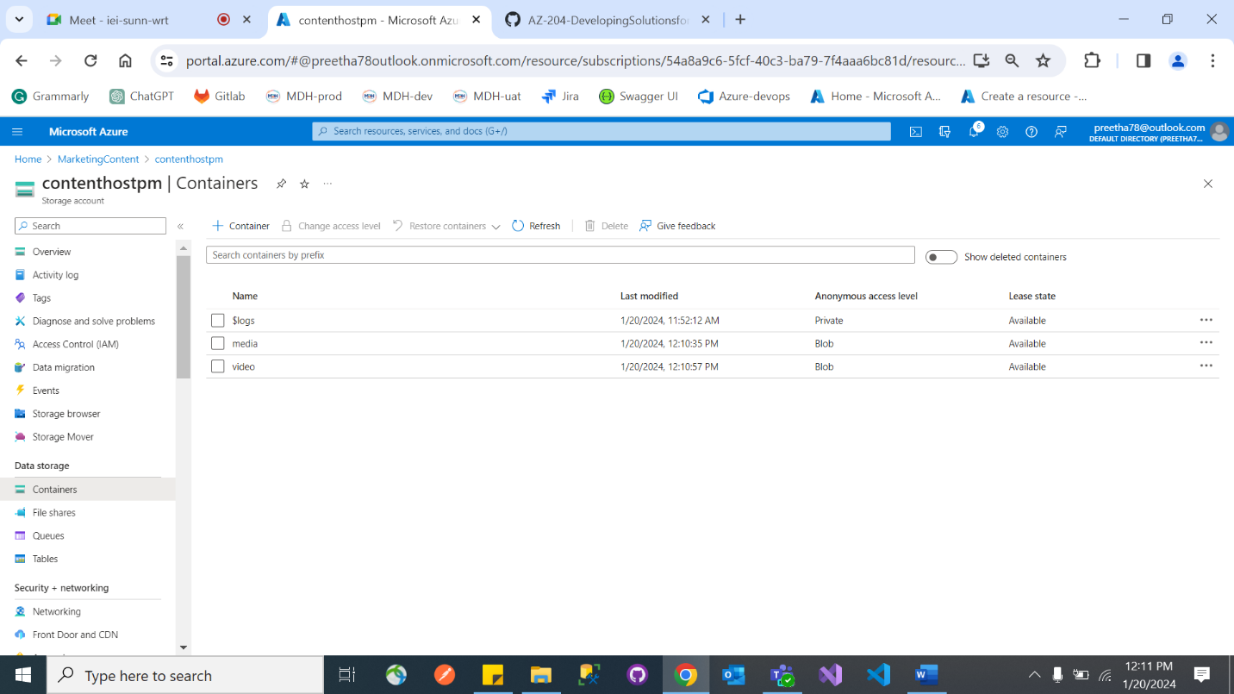

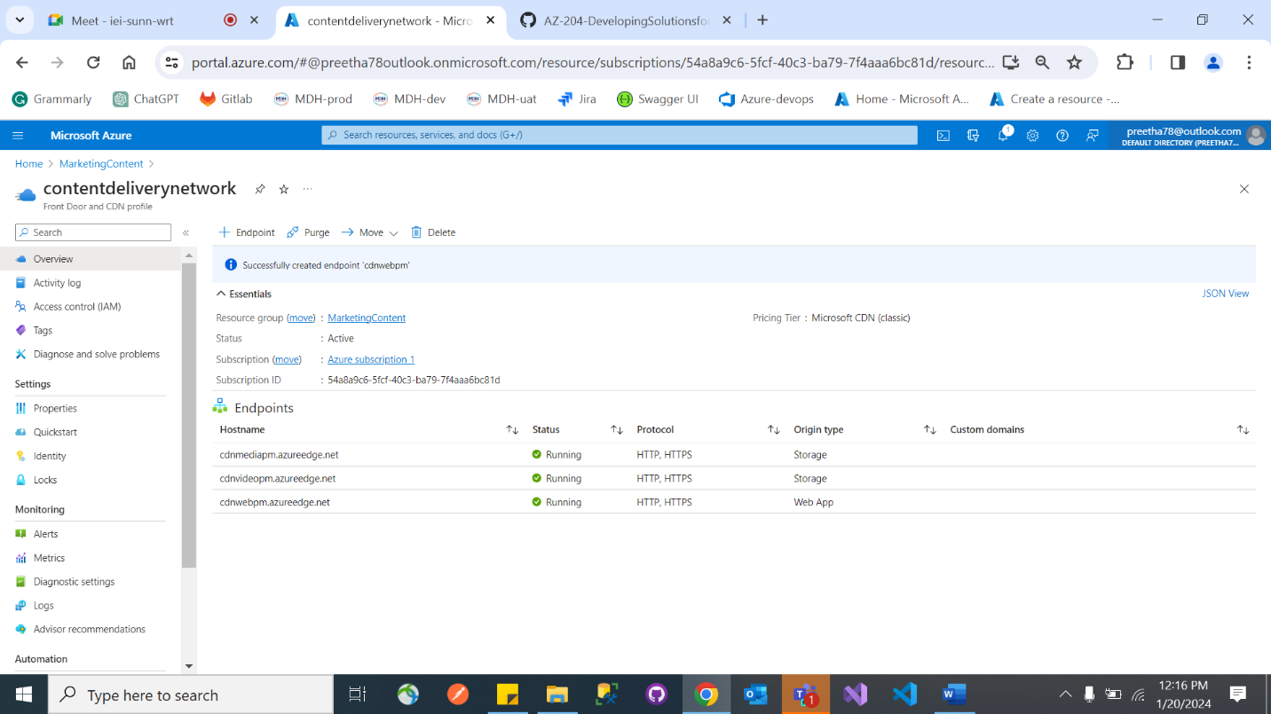

**Exercise 3:** Upload and configure static web content

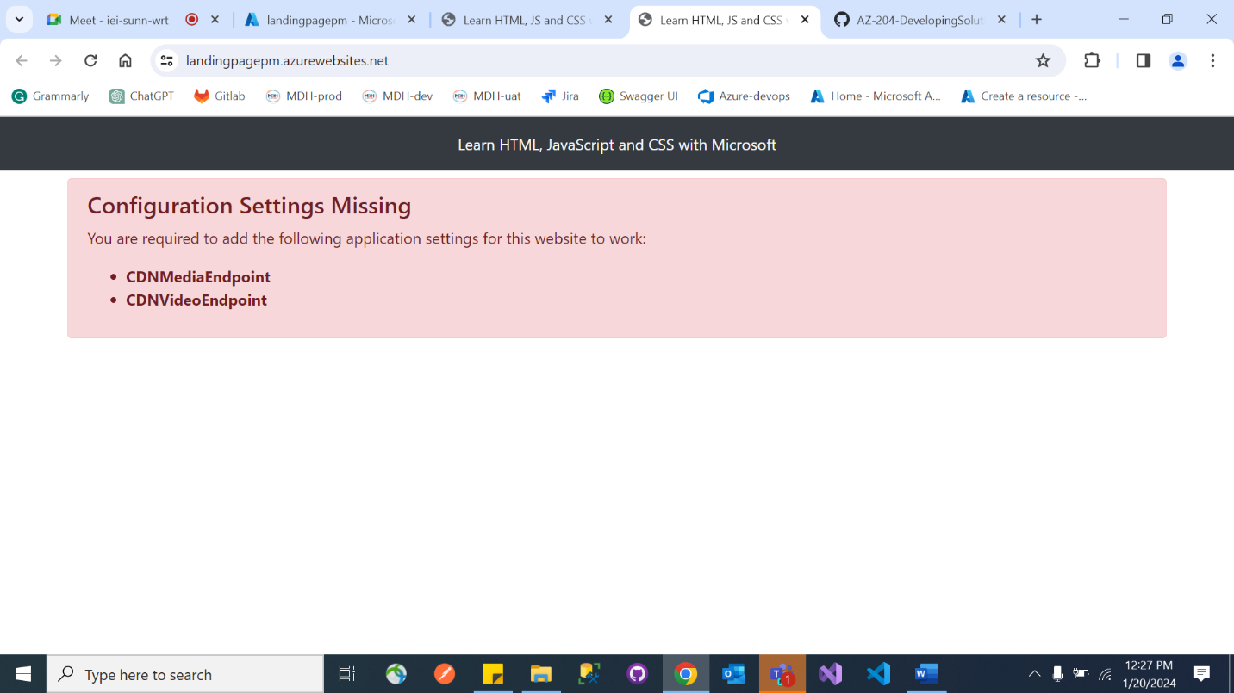

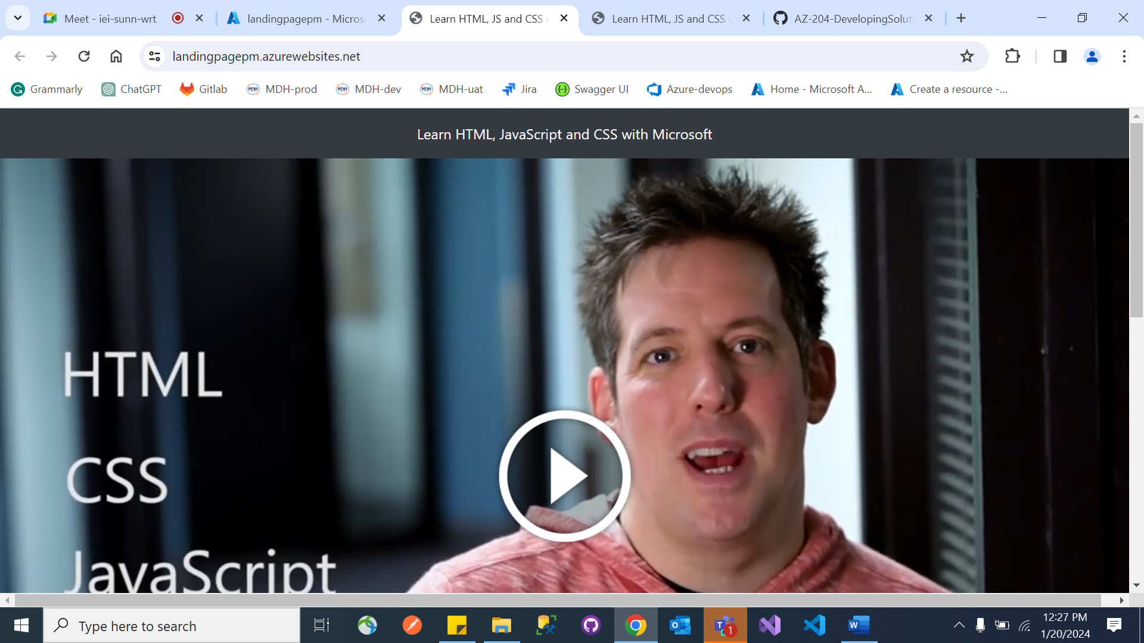

**Exercise 4:** Use Content Delivery Network endpoints

